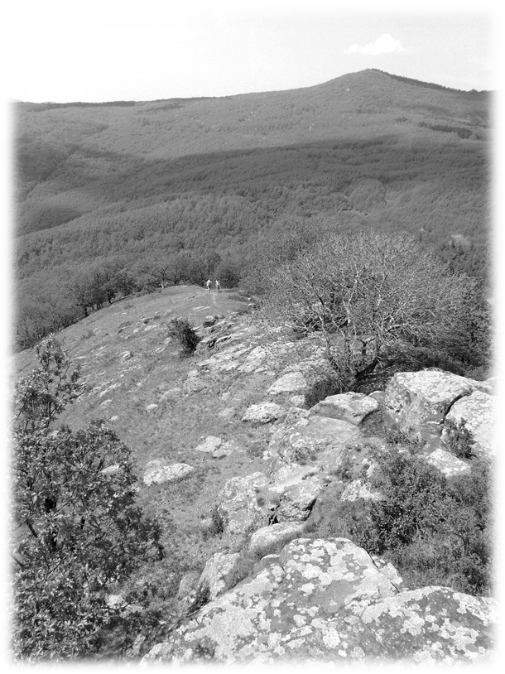

MÁTRA 115, 88
COMMUNITY TRAIL
The 12th
6-7 of June 2015

Mátra 115 Community Trail
On 6th and 7th of June 2015 we organise Mátra 115 trail for the 12th occasion.
We’ve not only chosen the route of the Trail for its own sake, but our aim is also to emphasize the opportunities of the Mátra mountains can afford us. The Mátra 115 trail links the most beautiful forests, mountains and villages of the Mátra in one long route.
The other main message of The Mátra 115 community trail is to show the strength of a civil community - we hope to your satisfaction.
Thank you for coming and taking part of the organising team by paying the participation fee. We expect you to come again next year either as a participant or as an organiser.
It is your own responsibility and risk to participate in Mátra 115.

This trail is only recommended for people in good health condition. The mission is to follow the designated route of the trail.
Contact numbers:
György Medveczky: + 36 30 9271876, Koppány Keresztesi: +36 20 5877144, Zsolt Prétor: +36 30 7409585

The Route of the Mátra 115 and 88

At any part of the route can be an unannounced checkpoint so please follow the route described here.

The Mátra 88 is a part of the Mátra 115. It cuts the distance between the cottage of Hidegkút (see point 12/b) and the peak of Tóthegyes, everything else is the same. Therefore you can decide only in Hidegkút which route you want to complete, either you’ve applied for 115 or 88 at the beginning. This is why we provide you with 2 different routes from Hidegkút – the first one is for the 115, while the second one is for the 88. If you arrived late to Hidegkút, we suggest you to continue with the 88, because even after a refreshing rest you’ll still have the time to complete it within 26 hours (that is the max. time to complete Mátra 88).
1. From the Castle of Kisnána follow the yellow stripe. After 2.43 km switch to yellow cross, that leads you out of the valley on the left hand side. At 5.2 km the blue circle comes from the right, take that sign up to the hill. At 5.62 there is a small by-pass to Csurgó-kút (fountain), there is a wooden bridge over that. Fill your bottles as this is the last water point till Kékes. At 6.58 km blue stripe comes from right, follow it from now on. After Jagus (6.92 km) the second peak comes, it is the checkpoint of Oroszlánvár (8.03 km), you can get a glass of water there.
2. Follow the blue stripe mainly on the ridge through to Kékestető (highest point of Hungary) (17.15 km), refreshment point.
3. Behind the restaurant find the yellow stripe towards Sombokor, cross the yellow cross at 19.06 km and switch to yellow square at 19.37 km. At 20.59 red stripe begins, follow that. At 21.21 you reach the public road junction at Galyatető-Parád (Mátra saddle). From here go towards Parád on road #24. After 480 m the trail turns left into the forest unexpectedly. Just step over the traffic barriers, where you see a paved parking lot on the right hand side - pay attention to this and you will not miss the sign. At 25.1 km you reach Parádsasvár (hairpin bend), from here follow red cross. Turn left to the village and follow the street named Rákóczi. After the Castle turn right and go up the hill. There is a community center on the right hand side of the street, opposite to the shop, about 40 m away. You’ll find buffet, check- and refreshment point there (27.2 km).

4. Follow the red cross upwards and after the blueberry bushes at 29.25 km the blue cross comes from the left. Follow red cross to Galyatető (TouristCentre) checkpoint at 31.36 km. Soup.

5. Still following the red cross upwards you reach the former red stripe at 31.96 km, currently being painted over with red triangles. Turn right, down towards Mátraalmás. You will find white base coat painting soon after, then red triangles, and after the next junction, turning left down to Mátraalmás, the original red stripes. At 33.02 you reach a wide forest road, follow it on the right. After 170 m turn left suddenly, leave this wide road onto a thinner road. Easy to miss! At 34.24 km switch to red cross, descend to Mátralmás on your left. The checkpoint is at Hegyipatak Vendéglő (pub). Refreshment point.

6. From the pub follow the red triangle up to Galyatető. Climb on to Galyavár (36.42 km). This sign joins the blue stripe at 37.29 km. Go left on the blue stripe back to Galyatető, and you reach again the checkpoint (TouristCentre) at 38.74 km.

7. Follow the blue cross (blue stripe has been repainted to blue cross!). After 190 m the blue cross turns right and separates from red cross, follow blue cross. After a 330 m more the trail suddenly turns left, heading to a young forest (39.36 km). Going along the blue cross you reach a forestry house called Nyírjes Erdészház (42.93 km). Walk 80 m in front of the building and turn on the right to follow the green square at 43.01 km. At 44.47 you reach a blacktop road, follow this on the left, after 320 m turn right into the forest (44.79km). At 45.74 km cross the green cross, go straight through the cut out forest. At the other end of the field you will find green square again and a stream (45.91 km). After the stream the route ascends again to Mátraháza. Checkpoint is in Mátra Centrum south from the parking lot (47.47 km). Refreshment point.

8. On the opposite side of the parking lot starts the yellow triangle sign, follow this, then at 48.67 km switch to the yellow square on your left, following the right edge of the clearing. The Bükkfa-kút (fountain) at 49.19 km works and has good water. At Lajosháza cross a bridge, the checkpoint is at the benches in front of the small hotel (51.93 km). Checkpoint, refreshment point.
9. Follow the yellow square cross the stream, ascend from the valley, on the ridge you reach the yellow stripe at 53.07 km, go on the right. Follow the fence of the hunting park. At 54.06 km starts the red cross, go on this (formerly it was red stripe but was painted over). The red stripe crosses a road at 58.97 km. Cross the road here using the red stripe and ascend. At 60.54 km you reach Hóvirág italbolt (a little pub) checkpoint in Mátraszentimre. Due to local hospitality ragout soup.
10. From the checkpoint depart to the green stripe. Pay attention at the edge of the village, when the blacktop ceases, here turn right (61.25 km). The next village is Mátraszentistván. The public fountain in front of Vidróczky csárda (restaurant) works (63.42 km). Departing from the village on the green stripe, turn right sharply at 63.74 km after a plate with the advertisement of Hotel Jäger. Continue to follow the green stripe up to the ridge (63.94 km), the path descends to Szorospatak. You cross some cart and car road perpendicularly, then you reach the stream at 67.31km. The sign leads you behind a house to a railed off place. Go on the outer side of the fence following the sign and then at the outer corner of the fence you arrive to the red stripe on the car road (67.4 km). From here follow the red stripe on the left. At 67.67 km there is Szorospatak checkpoint in front of the camp. Refreshment point. You can have massage here.
11. Follow the road. At 68.22 km the red stripe leaves it. At 69.58 km you reach the road again, cross it keeping little bit to your right. On a clearing at around 71 km the red cross comes from the right, here go on the left, then on the path in the young forest. At 71.9 km you reach one of the coolest places of Hungary: the Hostel of Ágasvár (Turistaház). It is real cottage on the mountain, they give you cakes, tea and the buffet is open.
12. Climb the peak of Ágasvár following the blue triangle (72.46 km), then back the same way. Leaving the tourist’s house behind continue on red and green (a fence prevents taking shortcuts through the yard), towards Vándor-forrás (spring). Shorten the route by turning right at the cave sign, then plastic ribbons mark the route. The Vándor-forrás at 73.72 km has plentiful water. Go on the right on the green stripe, cross the stream after 350 m and walk up to Fallóskút.
12/b Descend from here on the yellow cross. After 100 m, when you reach the main road turn on the right. Go 790 m on it, then at 77.0 km you should turn on the left onto a cart road. Do not follow the yellow cross from here! Instead follow the plastic bands. At 78.36 km you reach again the main road (you are back to yellow cross again), follow this towards Mátrakeresztes. At the edge of the village you reach a bridge (78.96 km), cross this and enter Mátrakeresztes. There is a public fountain beside the road. At 79.36 km there is again a stone bridge, across it there is the yellow stripe, turn the left on this, ascend on the Körtélyes street, and leave the village. At 81.63 km you reach up to Hidegkút saddle, from here it is only 300 m to another cool place called Hidegkút Turistaház (cottage). Checkpoint at 81.94 km. Refreshment point. You can have massage here.

13. Go further on the yellow stripe. Leave the wide road at 83.11 km. Here you should turn on the right into a pine forest on a pale path. After 740 m at 83.85 km you should suddenly turn on the right into the forest, leaving the cart road. At the ruins of Nagyparlag (85.09 km) you will see the green square, go down on this on the right into the valley (86.21 km). Here switch to green stripe on the left, but only for 510 m long, until you reach the green triangle at 86.72 km. From here turn right and up on the green triangle, following the valley for some time. The green triangle path is not easy, the forest is beautiful but the path is rocky, uneasy to walk on. Go up to Muzsla saddle (89.72 km). Here turn on the left on the red stripe to Muzsla hill (90.01 km). Checkpoint, banana, cup of water.
14. Further on the red stripe you descend steeply, and on the field of Nagy-Koncsúr (92.62 km) you’ll have a panoramic view. Then there is a sharp left-turn (95.08 km), which is marked by a plate as well. The green stripe is quite close to here (95.53 km). At the crossing of the signs there is the Diós-patak checkpoint, refreshment point.
15. Depart on the left down on the green stripe to Galagonyás-bérc (ridge). The red cross joins at 97.84 km. You should go 280 m on the ridge then turn on the right down. You reach to a corner of an orchard, here you should turn on the left to the bushes on a path at 98.48km. At 99.12 km you reach the Zám-patak (stream), switch to yellow cross from here, cross the stream on the right. The steep side of János-vára goes up just opposite. At 101.02 km you cross the yellow stripe, go further on yellow cross. At Kénes-forrás (spring) the water is good, and it is full of mineral ingredients. The spring is just before the stream right from the yellow cross path, surrounded by plants from which
you will hardly see it. After crossing the stream you should climb up to Mészpest, straight up on the steep side. Another small valley at 102.76 km, and then you are ascending on the side of Havas till a cart road at 102.85 km. Turn on the right here and go further 170 m. Turn sharply on the left. Many maps show yellow triangle but this is yellow cross. On the top there is a checkpoint (Havas) at 104.51 km, cakes, cup of water.
16. Descend on the yellow cross a kilometre, then go into the forest with an abrupt left-turn at 105.49 km. At 106.14 km you reach a cart road, follow it to the car road of Fajzatpuszta (107.66 km). Checkpoint at the blacktop. Refreshment point.
17. Follow the yellow cross to Káva. 50 m before the top switch to yellow triangle (110.01 km), you reach the top of it at 110.06 km. Descend to yellow cross and continue bending on the left still on the yellow cross. You reach a saddle. Ignore the table that might show you the wrong way, and go further on the yellow cross. At 112.74 km you reach the green square, go on the right 300 m, here comes the green triangle. Turn on the left, after 510 m you reach the foot of Tót-hegyes, here you should go on the right on a narrow path to the peak. Checkpoint at 113.91 km, water and cakes.
18. Descend further 300 m on the green triangle, and when you reach again the narrow path turn right out to green cross (114.33 km), there is a signpost showing a junction. Go further 350 m on the green cross, then the green square departs on the right at 114.68 km, follow it carefully, there _is_ sign, but path only occasionally. After 550 m at Babik-kút (fountain) field, you reach the green triangle. The fountain is over the small house, it is worth doing this 30 m by-pass, as you can refresh your energy by the water. You should follow the green triangle, here comes the last hill called Világos-hegy (116.96 km), checkpoint, water.
19. Cross the field with the remains of a former fortress rampart, down steeply. At 118.52 / 89.25 you reach a forestry road. Turn left, but leave the road when it turns left and head towards the young forest, following a trail. After 800 m turn right at right angles looking for the green cross sign, which starts here. Reaching the blacktop road leave the green cross and head straight downwards along the plastic ribbons. In the valley proceed a bit left. Where the road turns right entering the forest, you have to cross the forest and the fields (there are no signs for 400 m, but plastic ribbons). You get to a cart road, follow it turning left up to the blacktop road. Follow this for 2.5 km. Before entering the village turn right towards Várhegy – finish line is only 1 km from here. Reaching the forest go downwards next to the fence taking a sharp left turn. You find yourself on the row of ancient cellars, and going down you reach the Danka stream. Past the footbridge the beautiful church from the age of Árpád is only a few steps away – get around, and run to the finish through the pedestrian crossing in front of the school.

You have finished! You showed respect to the Mátra, and we grace you, congratulations! Come again next year!

Important
Racers, crew, and staff must not litter, mar, or pollute the landscape or environment.
Please do not throw away anything in the woods
Bus timetable
Gyöngyöspata (községháza) – Gyöngyös (20 minutes)
Saturday: 14.11, 15:05, 15:36, 16:46, 18:36, 20:41
Sunday: 4:35, 7:16, 8:15, 12:41, 14:11, 14:56, 16:48, 17:26, 18:36, 20:41Saturday: 15.45, 18:45

Our sponsors:
- Ágasvári Turistaház: http://www.agasvar.hu/
- Barangolók Bt., kitűző és egyéb ttúra anyagok készítése
- Egererdő Zrt. http://www.egererdo.hu
- Galyatető Turistacentrum:
- Gyöngyöstarján Önkormányzata: http://www.gyongyostarjan.hu
- Hanák Kolos Turista Egyesület: http://www.matraberc.hu/
- Hérics Turista Egyesület: http://herics.hu
- Hidegkúti Turistaház: http://www.hidegkutituristahaz.hu/
- Jász Tész Kft. http://jasz-tesz.hu
- Kékes Turista Egyesület: http://www.kekesturista.hu/
- Kilátó Vendégház és Étterem: https://www.facebook.com/kilatovendeghaz
- Kisnána Önkormányzata: http://www.kisnana.hu
- Magyar Sportturisztikai Szövetség http://www.mstsz.hu
- Mátra 60: http://www.muzsla.hu
- Tető Étterem, Kékestető: http://www.kekesteto.hu
- Mátraszentimre Önkormányzata: http://www.matraszentimre.hu/
- Szabó Méhészet:http://szabomeheszet.hu

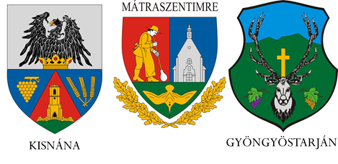
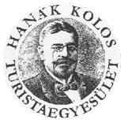


Fajzatpuszta  19:00 – 9:20  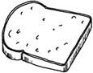  115: 107,66 |  | Tót-hegyes  16:00 – 10:45  115: 113,91  88: 84,64 |  | Világos-hegy  16:30-11:30  115: 116,96  88: 87,69 | Gyöngyöspata (school)  17:00-13:00  115: 124,04  88: 94,77  
Unannounced checkpoints
Startnumber:  Name:  Telephone number: |  |  | Meal ticket  |  |  | Kisnána Castle (start)  7.00
Oroszlánvár  7.30 – 9:00  115, 88: 8,03 | Kékestető, Sas-síház  (ski house)  8:30 - 11:00  115,88: 17,15 |  | Parádsasvár, Pub  9:00 – 12.45  115, 88: 26,6 |  |  | Galyatető, TouristCentre  9:45 – 14:30  115,88: 31,36
Mátraalmás, Hegyipatak (restaurant)  10:30 – 15:30  115, 88: 34,83 | Galyatető, TouristCentre  9:45 – 16:15  115, 88: 38,74 |  | Mátraháza, the building of Mátra Centrum  11:30-18:15  115, 88: 47,47 |  |  | Lajosháza  12:00 – 19:15  115, 88: 51,93
Mátraszentimre, Hóvirág-italbolt (pub)  13:00 - 21:15  115, 88: 60,54 | Szorospatak, Ifjúsági tábor (youth camp)  13:45 – 23:00  115, 88:67,67 |  | Ágasvár-th. (cottage)  14:15 – 1:00  115, 88:71,9 |  |  | Ágasvár csúcs  (the peak)  14:30 – 00:30  115, 88: 72,46
Hidegkúti-th. (cottage)  15:00 – 2:15, 88-on tovább! 115, 88: 81,94 | Muzsla (saddle)  16:15 – 4:30  115: 90,01 |  | Diós-patak (stream)  17:00 – 6:00  115: 95,53 |  |  | Havas (peak)  18:00 – 8:20  115: 104,51

